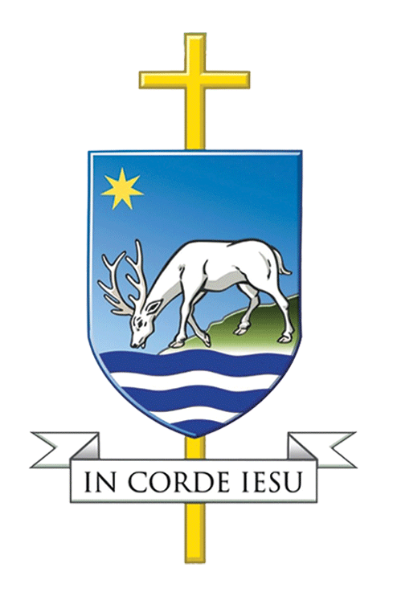

CATHOLIC DIOCESE OF PORTSMOUTH

Governor Recruitment Article

Our Catholic Schools need you!
Are you being called to serve as a foundation governor, helping our schools live out Bishop Philip’s vision?
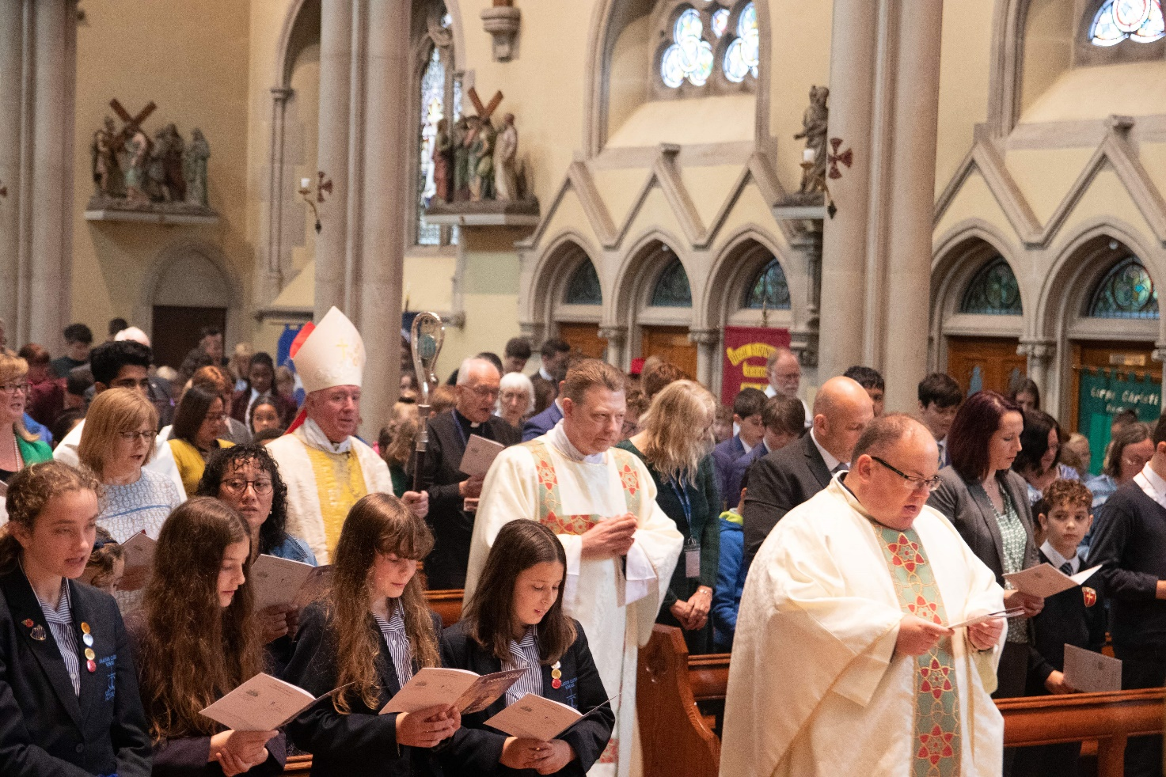
‘Catholic parishes and Catholic schools exist to make Jesus Christ better known and better loved. The context for this mission in schools is always that they are places of educational excellence, where all can grow in holiness as stewards of God’s creation. A school’s concern is to support families in the education of their children, especially their responsibility to help their children develop a personal relationship with God in Jesus Christ. The school therefore uses all the resources and expertise available for the harmonious physical, intellectual, moral and spiritual development of the young people in its care. In cooperation with the bishop, with parishes and with families, the school coordinates its activity to bring to full potential the gifts, talents and personalities of those young people for whom it is responsible.’
‘That They May Have Life’, Bishop Philip Egan, 2015
Across the diocese we have 412 foundation governors, serving on the governing bodies of 56 maintained schools and academies. We are very grateful to them for the support and challenge they provide for our schools and for the work they do to help bring about the Bishop’s vision of ‘Bringing people closer to Jesus Christ through His Church’.
With this large number of governors to recruit we are always looking for suitable parishioners to join them. We currently have 69 vacancies for foundation governors across 25 of our schools.
What is a foundation governor?
Foundation governors are volunteers who serve as the Bishop’s representative to assist in leading our Catholic schools. They work alongside other governors to form a governing body who are responsible for the strategic direction of the school. They are involved in decisions about all aspects of the school – such as buildings and budgets, monitoring standards and the Catholic ethos. Foundation governors take a particular interest and responsibility for admissions to the school, the employment of staff, Religious Education, Relationship Education, the prayer life of the school and for ensuring that the Bishop's directives are implemented. Foundation governors have the further duty of assisting the Bishop in his role as first teacher and leader of the diocese. The governors help determine the future for pupils attending our schools.
‘I've been a foundation governor for a number of years, the role is incredibly fulfilling, being able to support and safeguard the Catholic ethos of our school is so important to me, to know that future generations will benefit from the grounding, love and care of the Catholic education that both my children and I received is well worth the time and commitment needed. I would encourage anyone to consider serving on a governing body.’
Sam Humphrey, St Walburga’s Catholic Primary School, Bournemouth
Nominees would not be expected to have a direct knowledge of current education law, of school organisation or governance but should be willing to learn and dedicate reasonable time to their responsibilities.
Most governors will attend full governing board meetings (normally 3 or 4 a year) and additional committee meetings. There may also be tasks to be completed between meetings and opportunities to visit the school. It is important to recognise that for most new governors it can all be a bit baffling to begin with and all need support. Training and advice will be provided by the diocese, the local authority and most crucially by fellow governors. You are not on your own, governors work as a team supporting and challenging the school leadership.
‘My Catholic faith is important to me and my family and when a vacancy arose at my local Catholic school, I applied to become a foundation governor. It was a surprise and a tremendous honour to be appointed as a Foundation Governor some 4 years ago. Over the years, I have found that you don't need a particular skill set or expertise in any subject matter or even a degree but you do need to be prepared to give your time, show commitment to the school and colleagues, a willingness to learn and take on new challenges, the ability to get along with people including stakeholders and a determination to see things through and not leave it to someone else to do. I have tried really hard to make a difference and when my time as a foundation governor is at an end, I would like to be able to say, I had a positive impact on the school and left it in a better place than when I joined.’
Ian Anderson, All Hallows Catholic Secondary School, Farnham

Why am I needed?
Are you:
- A practising Catholic?
- Interested in the education of young people?
- Passionate about Catholic education and its vital role in advancing the mission of the Church?
- Prepared to work as part of a team responsible for the strategic direction of one of our Catholic schools?
Then you could be just what our schools are looking for!
‘Being a governor is a great service to the local Catholic community, entails a consistent commitment of time and good will, being able to listen, ask questions, encourage and sometimes challenge. It is a rewarding role.’
Vicky Hummell, Christ the King, Reading
You do not need teaching experience and it is useful to bring skills from all areas of your life, such as financial, human resources, buildings, health and safety, safeguarding, parish work and community work. Schools are also looking for governors who reflect the ethnic, cultural and social background of their catchment area.
Foundation governors have an important part to play in ensuring the Catholic character of our schools and in building the community of Catholic schools throughout the diocese. Without them our schools are in jeopardy of losing their distinctiveness which will have a significant impact on the future lives of our children.
Governors are appointed for a 4-year term of office, after which they can be reappointed or pass the role on to someone else. Consequently, we are always seeking new foundation governors to serve in our schools. We currently have 69 vacancies across the diocese. To see if a school near you is looking for the right person to serve on their governing body visit www.casoportsmouth.org.uk/foundation-governor-vacancies/
‘Being a foundation governor has allowed me to be a more practical, practising Catholic. I have always worked as a public servant and being in school governance has enabled me to not only broaden my public service but to do so within the context of my Church and my faith – it is a “win-win” situation.’
Captain Marc Evans, Chair of Governors, Oaklands Catholic Secondary School and Sixth Form College

Where can I find out more?
If you have any questions about being a foundation governor then you email the diocesan Catholic Academies and Schools Office (governors@portsmouthdiocese.org.uk) and one of the CASO staff will get back to you.
If you are interested in a particular school then as a first step check out the school’s website and if still interested make contact with them to find out more about becoming a foundation governor there.
Visit the CASO website (www.casoportsmouth.org.uk) and look through the pages dedicated to governors.

How can I apply?
If you want to apply to a particular school, firstly, make contact to check the school still has a current vacancy, and to see if they are looking for applicants with a particular skill set. The next step would then be to complete a foundation governor nomination form, this can be obtained direct from the school, or from the CASO website.
We are also very interested in applicants who are prepared to give service in a locality further afield than their own parish school. As above, the next step would be to complete a foundation governor nomination form.
We look forward to receiving your completed nomination form and working with you in the future.
‘I consider being a foundation governor to be a great privilege - it’s fantastic having a window into a professional area of work that is so very different from my own area of expertise - even better when you know that your endeavours have had a positive impact on outcomes for children!’
Liz Holford, St Peter’s, Waterlooville

