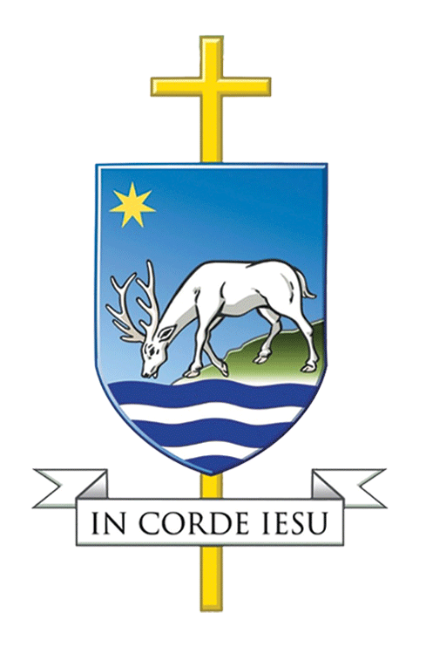

CATHOLIC DIOCESE OF PORTSMOUTH

Foundation Governors – Frequently Asked Questions

FOUNDATION GOVERNORS – FREQUENTLY ASKED QUESTIONS

What defines a Catholic school?
Canon 803 provides the definition of a Catholic school. Canon 803 sub-section 1 provides that a school is Catholic if:
- It is controlled by a diocese or religious order; or
- It is acknowledged in a written document as Catholic by the diocesan bishop.

Canon 803 subsection 3 provides that no school, even if it is Catholic, may use the title ‘Catholic school’ without the consent of the bishop.

What is the Trust Deed?
Most Catholic schools, and the land they are built on, are owned by the diocese. They are held in charitable trusts by diocesan trustees, appointed by the bishop. The role of the diocesan trustees is to safeguard the interests of the Catholic community as a whole in the diocese and to serve its needs. Other Catholic schools, mainly owned by religious orders, have their own trustees, but are nevertheless within the authority of the bishop.

Catholic schools are provided by the trustees for the purposes set out in their governing documents, known as the trust deed. Most trust deeds state that the school is provided ‘for the maintenance and advancement of the Roman Catholic religion’, and the provisions of canon law form part of the trust deed in every Catholic school. Under charity and education law, the school is regulated by its trust deed, and the school’s Instrument of Government must reflect those requirements.

What is the role of a Foundation Governor in a Catholic school?
Foundation governors are appointed by the bishop, or religious order, to represent their interests and those of the Catholic community as a whole. Foundation governors play a leading role in the Catholic community: they collaborate with the bishop in his ministry in education. It is, therefore, important for them to:
- Know and implement the bishop’s policies on education, including religious education;
- Represent those policies to the governing body;
- Understand and promote the distinctive nature of Catholic education;
- Act for the good of Catholic education as a whole within the diocese, considering not only the interests of the individual school or college, but the interests of other schools and colleges;
- Respond to the needs of the Catholic community as a whole, as represented by the bishop;
- Secure the long-term future of Catholic education;
- Always act in accordance with the mind of the bishop.

What additional roles does the Governing Body have in a Catholic school?
The governing body of a Catholic school occupies and conducts the school on behalf of their trustees and under the supervision of the diocesan bishop as the occupier of the premises, proprietor of the undertaking, and employer of the staff. It occupies the school subject to the parameters laid down by their trustees, and ultimately any decisions relating to the land and buildings rest with the trustees, except in so far as these have been delegated to the governing body by the trustees.

All governors of Catholic maintained schools have legal rights and responsibilities which ensure that they safeguard and promote their school’s denominational character. These rights and responsibilities have been recognised by Government as central to the continuing success of Catholic education. The following are key aspects of the governing body’s legal duties in voluntary aided schools relating to their religious character.

Appointment of Teachers
Since all Catholic maintained schools are voluntary aided, the governing body of those schools is the employer of staff. In Catholic voluntary academies the board of directors of the academy trust is the employer of staff. For the purposes of this paper, the term ‘school(s)’ includes academies.
For the purposes of protecting the Catholic character of the schools, the bishops have collectively issued the Bishops’ Memorandum on the Appointment of Teachers in Catholic Schools. The Memorandum sets down the bishops’ expectation that the employers of staff in Catholic schools will issue clear guidelines about the Catholic character of the education and life in their school and will issue the appropriate contract of employment and associated documentation as published by the Catholic Education Service (“CES”).

The Memorandum sets out as a minimum requirement, that in all Catholic schools the Headteacher, Deputy Headteacher and the Head or Co-ordinator of Religious Education must be a practising Catholic. The Memorandum is due to be updated shortly to reflect the fact that there are different emerging terms for senior school leaders, such as Head of School, Executive Head, Associate Headteacher etc, and the Bishops’ Memorandum will be amended to reflect the fact that those with overall responsibility for the day to day management of the school, and the person who is the second most senior person in the leadership team, regardless of the descriptor applied to their role, will be required to be practising Catholics. The Memorandum also refers to the employment of practising Catholics for other teaching posts within the school as being a “high priority” whilst recognising the contribution of teachers of other traditions.

In Catholic schools in England it is possible to objectively justify that a support staff post can only be filled by a practising Catholic. This is, of course, subject to the school being able to satisfy the requirements for ‘objective justification’ and the CES always advises that governing bodies of Catholic schools in England take legal advice before applying such a requirement. This provision does not apply in Wales i.e. there can never be a justification for a requirement that a support staff post be filled only by a practising Catholic.

It is important to ensure that the Catholic character of the school is preserved and developed. In the CES model contracts all school staff are required to have regard to the Catholic character of the school at all times. All staff will be expected to be conscientious and loyal to the aims and objectives of the school and not to act in any way that would be detrimental or prejudicial. Senior levels of staff will be required to maintain and develop the Catholic character of their school. Furthermore all staff are bound to carry out their contractual duties in accordance with the requirements of canon law in respect of the governance of the Catholic character of the school, and the Trust Deed and Instrument of Government of the school.

The governing body, as the employer, is required to ensure that the CES model documents are used in their school. Furthermore they are required to ensure that provisions of the contractual documents are fulfilled and to take steps in relation to any breaches of contract, taking advice from their diocese. The CES model workplace policies provide that where disciplinary allegations concern misconduct which could bring the Catholic character of the school into disrepute then the school must notify the diocese.

Admissions
As a voluntary aided school, the governing body of every Catholic school is the admission authority. The governing body is therefore responsible for drawing up its own admission policy for the school. This must of course comply with legislation and with the School Admissions Code.
Catholic maintained schools are of course permitted to give priority first and foremost to Catholic children, and this is a legal requirement in some dioceses. The School Admissions Code provides for the admission authority of the school to follow any guidance issued by the Church or religious authority where preference is given on the basis of faith criteria.

All Catholic dioceses will provide guidance to their schools setting out the bishop’s requirements in relation to his schools’ admission arrangements. The bishop will expect his requirements to be followed, and these will include the requirement that priority is given to Catholic children.

The Curriculum
The governing body of a Catholic maintained school is responsible for policy relating to the whole curriculum, including religious education. This ensures that the curriculum of the school, including all the subjects of the National Curriculum, is taught in the light of the Gospel values and actively promotes the spiritual and moral development of the pupils. Foundation governors have special responsibility for the religious education curriculum and have a duty to ensure that it is taught in accordance with the Curriculum Directory and the bishop’s policy.

Where can I access training for my role as a foundation governor?
The CES have arranged for online training for governors. This free online training resource for all governors of Catholic schools is designed by the Catholic Education Service.

The governance training is for all those involved in governance in schools and academies of all abilities and experience. This includes governors, local governors and directors of Catholic Multi Academy Trust Companies.

You can access the training here: http://formatio-ces.org/moodle/login/index.php
The training consists of five modules to support you in your particular role as governor of a Catholic school:
- An introduction to Catholic Education – available now
- The environment of a Catholic school – available now
- Strategic Leadership – available Spring 2020
- Accountability – available Spring 2020
- Financial Performance – available Spring 2020

Click on this link to access full joining instructions.

Occasionally, the Catholic Academies and Schools Office also offer training for governors. Check their Training and Briefings webpage for details of any forthcoming courses or briefings.

How are Catholic schools and academies accountable?
Catholic schools and academies have the same accountability to the local authority/Department for Education/Welsh Government as non-Catholic schools and academies. In addition to this, they are also subject to an extra inspection regime to provide accountability to their diocesan bishop that high academic standards and the Catholic life of the school are maintained.

Who funds Catholic schools?
The school buildings and land of Catholic schools are owned by the Catholic Church. The Church provides these premises, at no charge, to enable the state to fulfil its obligation to provide education for the population. The day to day running costs of Catholic schools are funded by the state in the same way that all schools are funded (either through local authority or DfE funding agreements). The Church covers 10% of the capital costs for the maintenance of the premises in all voluntary aided schools. Through this arrangement the Catholic Church saves the taxpayer tens of millions of pounds a year.

Whom can I contact in the diocese if I have a query?
The support for schools in the Diocese of Portsmouth is organised through the Catholic Academies and Schools Office (CASO). Their website at www.casoportsmouth.gov.uk will be able to provide answers to many of your potential queries. Within CASO the following individuals are also able to offer support and guidance.

Catherine Hobbs – Director for Education (email: chobbs@portsmouthdiocese.org.uk )
Robert Dare - Diocesan Schools Support Officer (Primary RE; s48 Inspections; admissions, CASO website and Governor Support) email: rdare@portsmouthdiocese.org.uk
David Walford – Secondary RE Adviser (email: dwalford@stgcc.co.uk )
Shelley Clerkin – Administration Officer (Foundation governor appointments) (email: governors@portsmouthdiocese.org.uk )
Sue Field – Admin Assistant (Diocesan Vacancies Bulletin) (email: schools@portsmouthdiocese.org.uk

If your query is linked to schools buildings you can contact the Estates Office.

What is a section 48 inspection?
If a school is designated as having a religious character, it'll have its denominational education and collective worship inspected under section 48 of the Education Act 2005. This is in addition to Ofsted inspections.

In the Diocese of Portsmouth s48 inspections are also referred to as s48 validations. To find out more about s48 inspections visit the relevant page on the CASO website - http://www.casoportsmouth.org.uk/self-review-and-validation/ This section on the website also includes guidance to school leaders and governors on keeping the school’s religious character under review.

What RE should be taught in the school?
The objectives of curriculum religious education for our schools are:
- To develop knowledge and understanding of the mystery of God and of Jesus Christ, of the Church, and of the central beliefs which Catholics hold.
- to develop awareness and appreciation of Catholic belief, understanding of its impact on personal and social behaviour and of the vital relationship between faith and life, life and faith.
- to encourage study and investigation.
- to develop appropriate skills: for example, ability to listen, to think critically, spiritually, ethically and theologically; to acquire knowledge and organise it effectively; to make informed judgements.
- To foster appropriate attitudes: for example, respect for truth, respect for the views of others; awareness of the spiritual, of moral responsibility, of the demands of religious commitment in everyday and especially the challenge of living in a multicultural, multi-faith society.

Curriculum RE should equate to 10% of the taught curriculum.

The Catholic Diocese of Portsmouth expects its primary aged children to be taught RE using the God Matters RE scheme, alongside the supplementary guidance provided by CASO. Pupils in Key Stage 3 are taught RE through the Open Door RE scheme. In Key Stage 4 pupils study one of the approved GCSE syllabi.

Further details on RE in the diocese can be found at http://www.casoportsmouth.org.uk/re-and-worship/

