RECOMMENDATIONS FOR RESPECTING AND VALUING SCHOOL PRAYER AND LITURGY

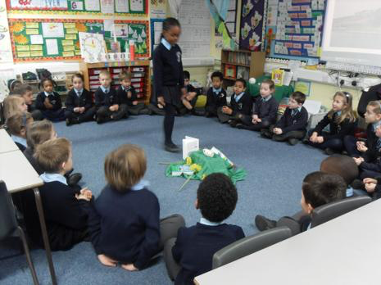
There is a danger, especially in the school setting, of the over-secularisation of liturgy. While it is to be recommended that we always be creative and endeavour to capture the imagination of the young, we still have the primary responsibility to make of our liturgies a truly prayerful event.

Our prayer and liturgical celebrations must reach the hearts of the faithful who are entitled to come into touch with the sacred.

The following are some recommendations that aim to safeguard school prayer and liturgy, be it class, key stage or whole school, while at the same time achieving a joyful and meaningful celebration in the school.

- Catechise well before your worship; in class develop the theme in imaginative ways. This will stimulate the pupils and the liturgy will be far more meaningful on the day. Achieve a well-worked and imaginative theme.
- Maximise student involvement but don’t overdo it!
- All to be welcomed and encouraged to participate, including other adults in the classroom. If children or adults have particular needs ensure this has been thought through beforehand.
- Many schools have limited physical resources and need to adapt classrooms, halls etc. before the liturgy can begin. See this as an opportunity – we can literally make a sacred space out of the most ordinary location. Praying outside in the school grounds or a local park or on a school trip can be truly spiritual.
- Ensure the prayer space is appropriate to the liturgical season and/or theme of the liturgy.
- Make sure you are not disturbed, consider putting a sign on the door to the room/space to alert those passing or about to enter but ensuring those who want to join you are made to feel welcome.
- Time. Ensure it is given the space in the school day to be fully appreciated and beneficial, don’t squeeze it in at the end of a session, allow time to move into and out of the liturgy.
- Endeavour to achieve a sensed of the sacred – we are on holy ground! “For where two or three gather in my name, there am I with them.” (Matthew 18:20)
- If you are not leading the worship personally liaise with the person who will be. Ensure they are in sympathy with the theme you want to explore, the atmosphere you want to engender.
- Ensure visitors, including parents, are welcomed and made aware of the expectations at the beginning of the session, consider asking everyone to pause in silent reflection before beginning in order to set the scene and the move into worship.
- Music is a ministry in itself, try and choose music that will, at all times, support the sacredness of the liturgy. There is no need to hold back on energy and joy as the occasion requires. However, remember it is not a performance, it is prayer through music. “They who sing pray twice” (St Augustine)
- Don’t be afraid to invite the pupils to compose their own songs, poems, reflections. They will not let you down. Neither be afraid to hold editorial authority over their submissions – it is all for the glory of God and therefore must be fitting for the celebration.
- IT has given us a powerful tool to be creative but remember, it must complement and not compete with the Word of God.
- Ensure due reverence is given to the Scripture, ideally this should be read direct from a Bible, taken reverently from the focal point, and the reading introduced and finished with the appropriate wording and response.
- The readings can sometimes be the weakest aspect of a liturgy. Ensure those reading have sight of it beforehand, have it explained to them if necessary, and have the opportunity to practice reading it out loud. Ensure the reading is appropriate for those participating and the liturgical season/event you are celebrating.
- Evaluate the worship afterwards. Questions you may ask yourself or those who prepared it include, ‘Did we achieve a sense of the Holy?’, ‘Did people come closer to God today as a result of our liturgy?’, ‘Did those participating leave with a clear sense of how the message of the scriptures can be taken away and lived out in their daily lives?’
- Finally, ensure you give yourself over to the worship as much as you can. You are a participant as much as those you are leading.

