Catholic Diocese of Portsmouth
PROGRESSION IN PUPIL LED PRAYER AND WORSHIP
INTRODUCTION
The Prayer and Liturgy Directory: To love you more dearly, makes reference to the key role pupils can play in supporting prayer and liturgy
4.2 School responsibilities in facilitating prayer, celebration of the word and liturgy
Pupil leadership - Pupils of various ages and abilities can take an active role in organising and leading prayer and liturgy in a meaningful and age-appropriate way throughout the school. In some settings, the school may choose to have a team of pupils whom they form and guide specifically for this role.
It is important to note that the expectations need to be age-appropriate. The overall responsibility for the quality of the prayer and worship remains with the pupils’ classteacher and great care must be taken to support the pupils in providing prayer and liturgy that is spiritual, reflective and engaging and fulfils the requirements of the Prayer and Liturgy Directory.
The PLD also contains useful information on the various liturgical ministries pupils can be asked to carry out
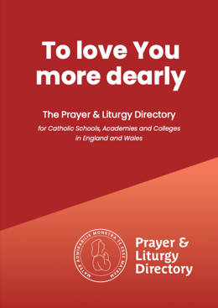
- The effective celebration of prayer and liturgy needs individuals and groups to assist with liturgical ministries in different ways. For those who assist to lead/pray/sing/serve worthily and well, they will require not only immediate preparation for the task in hand, but also longer-term formation to undertake these roles. A key dimension of the role of a liturgical minister is to help engage the participation of the liturgical assembly, that is, all those who are gathered to celebrate…..
- Those who assist in the liturgy, whether by leading, reading, or singing, serve by facilitating the participation of all who are present at the liturgical assembly. They should be well formed and properly prepared because it is important in our worship of God that we offer something which is worthy. ….
- Allocating roles, such as reading or leading intercessions, should not be treated as a means of distributing tasks to pupils and staff in order to generate participation.
Although the above is primarily talking about liturgies, the same principles will apply to whenever the community gather to worship together.

The Prayer and Liturgy Directory also contains advice on when to introduce common prayers to the pupils (section 9.5 common prayers).
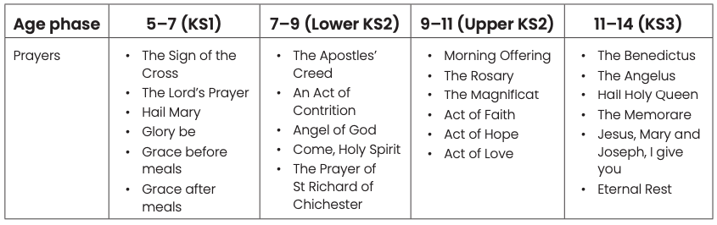
Within the Catholic Schools Inspectorate Inspection Framework there are frequent references to evaluating how schools support pupils in being increasingly involved in and taking greater ownership of their prayer and liturgy.
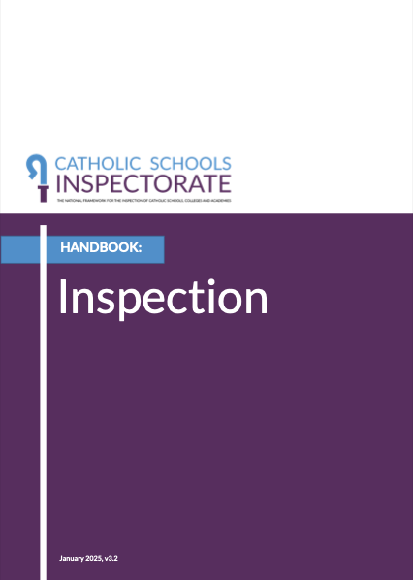
Inspectors will take into account:
- the extent to which pupils are engaged by and participate in prayer and liturgy;
- the extent to which pupils are able to articulate an understanding of different ways of praying and the cycle of the liturgical year;
- the ability of pupils to work with others to prepare prayer and liturgy and how well formed they are to undertake liturgical ministries;
- the ability of students to reflect on their experience of prayer and liturgy and the extent to which this reflection inspires them to action.
- how skilled relevant staff are in helping pupils to plan and lead well-constructed celebrations of prayer and liturgy according to the norms of the Church;
- the effectiveness of leaders, including chaplains, in facilitating pupils and staff to provide high quality prayer and liturgy across the school, in a manner that reflects the age and capacity of participants;
- the extent to which evaluation of prayer and liturgy is central to the school’s annual review cycle and how effectively leaders, including governors, implement improvements as a result.

It is important to note that the above statements refer to all schools and all ages of pupils and need to be interpreted to take account of the age and ability of the pupils involved. As stated above, the overall responsibility for the quality of the prayer, celebration of the word and liturgy remains with the pupils’ classteacher and great care must be taken to support the pupils in providing prayer and liturgy that is spiritual, reflective and engaging and fulfils the requirements of the Prayer and Liturgy Directory.
This document attempts to set out a model for how pupils’ involvement and leadership of their prayer, celebration of the word and liturgy can be built on year on year in our primary schools. The expectation would be that schools would adapt the model to reflect their own situation. The model is progressive with the assumption that each year adds to the content of previous years.
The framework is set out in phases to ensure it also covers mixed age classes, however, if a school has single age year groups then they are free to take each phase and divide it into year groups.

Year Group | Pupil Expectations |  | School/Adult planned prayers, celebration of the word and liturgies – different sized groups | Resources
Early Years | By Advent all children should be able to:  - Join in with the sign of the cross and any prayer the school regularly uses at the start of worship, e.g. the school prayer, welcome prayer.  - Join in the set morning, lunchtime and end of the day prayers.  - Help in the setting up of the prayer focal point as modelled by the classteacher.  - Be involved in an aspect of class prayer e.g. passing around a symbol or prayer focus.  By the end of the Summer term all children should have the opportunity to:  - Join in saying Our Father, Hail Mary and Glory be – led by an adult.  - Talk about prayer times as a class, with their thoughts recorded on the proforma by an adult. | - All children know the routine(s) for gathering.  - As a class, plan a celebration of the word for Easter (or other key liturgical celebration) with some children suggesting prayers and focal point with adult support.  Some children should have the opportunity to:  - Set up the focal point for worship according to liturgical season/RE topic guided by an adult. | - Staff create the appropriate atmosphere.  - Staff model reverence and school agreed “postures” and lead responses/prayers/  singing e.g. during prayer - hands together/out-stretched to enable pupils to be able to respond.  - Build to 30 secs silent reflection – children could be involved by ringing a bell as a signal to start.  - Encourage opportunities for spontaneous prayer.  - Pupils contribute to Class prayer book/prayer tree.  - Whole school prayer and liturgies throughout the year e.g. Remembrance, Harvest, Advent and Lent penitential liturgies, Holyday Masses and Liturgies, Ash Wednesday, beginning and end of year. | Prayer box of cloths, Bible, Candle, artefacts that is added to during the year.  Proforma for evaluating celebrations of the word.  Record pupil involvement in planning and preparing acts of worship through photos.  Home link e.g. prayer bag, travelling nativity.

Year Group | Pupil Expectations |  | School/Adult planned prayers, celebration of the word and liturgies – different sized groups | Resources
Years 1 and 2 | By the end of Y2 all children can:  - Plan and prepare focal point for worship according to liturgical season/RE topic guided by an adult.  - Lead the welcome including the Sign of the Cross and The Lord be with you… with children responding appropriately. Adult to prompt/support where needed.  - Respond with spontaneous prayer (e.g. prayer pebbles) relevant to the theme of the celebration of the word.  - Evaluate wider celebrations of the word or other worships as a class, recorded by an adult on the proforma - focussing on a different aspect each time.  By the end of Y2 most children can:  - With adult support can generate their own way of gathering to begin the liturgy.  - Lead Our Father, Hail Mary and Glory Be, morning, lunch and end of the day prayers. (By end of Year 2) | Some children:  - Participate in saying traditional beginning and end for readings and scripture.  - With adult support and training, and appropriate to their age and ability, take on the role of simple ministries, e.g. ministry of welcome, simple reading, sharing a prayer, preparing a simple focal point.  - By Summer 2, Yr1 with support from an adult contribute to the planning of an aspect of a class celebration of the word or other simple prayer session, for example, choosing scripture or music with adults identifying theme and offering a limited range of options.  - By Summer 2, Yr2 with support from an adult contribute to the planning for most elements of a class celebration of the word or other simple prayer session – for example, choosing scripture and other components from a limited range offered to them. | - Build to 1-2 minutes guided meditation and silent reflection.  - Encourage opportunities for spontaneous prayer beyond planned liturgy times.  - Pupils contribute to Class prayer book/prayer tree  - Whole school occasions of prayer and liturgy throughout the year e.g. Remembrance, Harvest, Advent and Lent, Penitential services, Holyday Masses and celebrations of the word, Ash Wednesday, beginning and end of year celebrations of the word. | Prayer resources to include cloths, Bibles, prayer stones, relevant artefacts.  Prompt card with responses during Mass e.g. the response to “The Lord be with you”  is “and with your spirit”  Beginning/End of scripture.  Proforma for planning evaluating liturgies.

 | Pupil Expectations |  | School/Adult planned prayers, celebration of the word and liturgies – different sized groups | Resources
Year Group | Word (Class based) | (Wider group based) |  | Resources
Years 3 and 4 | All Children given the opportunity to:  - Ensure the class prayer space correctly reflects the liturgical season  - Lead traditional beginning and end for readings and scripture  - Lead Our Father, Hail Mary and Glory Be, School Prayer, morning, lunch and end of the day prayers.  - Become familiar with set prayers for Years 3 and 4 – Apostles Creed, Act of Contrition, Angel of God, Come Holy Spirit, Prayer of St Richard of Chichester.  - Evaluate celebrations of the word as a group and class, on the proforma guided by an adult.  Some children given the opportunity to:  - Independently generate their own way of gathering to begin the worship and liturgy, including the welcome.  - Guided by adult, plan and lead class prayer and part of celebrations of the word, including a selection from - choosing scripture relevant to the liturgical year, a response to the scripture (explanation and links made to scripture), their own mission/going out for children to complete the liturgy e.g. link to Catholic social teaching, appropriate music and focal point. | All Children given the opportunity to:  - Participate in prayers linked to sacramental preparation eg Act of Contrition; Eucharistic Prayer; Gloria or liturgical season eg The Rosary, Stations of the Cross.  - Genuflect when they enter/leave the church – end of pew.  - Bow in front of the altar.  - Participate in aspects of the Mass  - Evaluate liturgies as a group and class, on the proforma guided by an adult.  Some children given the opportunity to:  - Guided by adult, plan and lead wider school prayer and liturgy including a selection from choosing scripture relevant to the liturgical year, a response to the scripture (explanation and links made to scripture) their own mission/going out for children to complete the liturgy. Eg link to CST, appropriate music and focal point  - Work with Parish Priest/ Chaplain/ RE leader/ headteacher/class teacher to reflect on the readings of class/phase Masses and write Introduction and Prayers of Intercession. | - Rosary – October and May  - Stations of the Cross  - 5 minutes guided meditation – children could be involved by ringing a bell as a signal to start.  - Encourage opportunities for spontaneous prayer beyond planned liturgy times – as part of the liturgy, response to joyful or sorrowful events (personal or wider community).  - Pupils contribute to Class prayer book/prayer tree  - If possible, join Parish Mass once per term.  - Support sacramental preparation e.g. First Holy Communion, Act of Contrition; Eucharistic Prayer; Gloria.  - Whole school prayer and liturgies throughout the year e.g., Remembrance, Harvest, Advent and Lent penitential liturgies, Holyday Masses and Liturgies, Ash Wednesday beginning and end of year, Phase Mass  - Some pupils are given opportunities to use their gifts to enhance the prayer and liturgies of the school through appropriate ministries. | Prayer resources to include cloths, Bibles, prayer stones, relevant artefacts.  Prompt card with responses during Mass e.g. the response to “The Lord be with you”  is “and with your spirit”  Beginning/End of scripture.  Proforma for planning evaluating liturgies.  Models of good practice.

 | Pupil Led and Pupil Expectations |  | School/Adult planned prayers, celebration of the word and liturgies – different sized groups | Resources
Year Group | (Class based) | (Wider group based) |  | Resources
Years 5 and 6 | All children can with an appropriate level of adult support (dependent on age, skills and experience)  - Plan and lead class prayer and aspects of celebrations of the word, including generating how they gather, choosing the form of the worship, the theme and appropriate scripture relevant to the liturgical year or to current events (school, local or world-wide), a response to the scripture (brief reflection and links made to scripture), quiet reflection time, key going forth message/ mission, (e.g. link to Catholic social teaching action), appropriate music and focal point.  - Plan and lead guided meditation.  - Lead Our Father, Hail Mary and Glory Be.  - Lead and re-write the morning, lunch and end of the day prayers to reflect the liturgical season, e.g. Advent, Lent.  - Evaluate prayer and liturgy as a group and class, giving reasons for their response and recommendations on the proforma – both guided by an adult and independently.  Some children can independently, with a final check by an appropriate adult, complete all the above. | All children can with an appropriate level of adult support (dependent on age, skills and experience)  - Participate and respond appropriately during Mass  - Genuflect when they enter the church – end of pew  - Bow in front of the altar  - Plan and lead liturgies and worship beyond their own class or phase which reflect the liturgical season, e.g. Advent and Lent Prayer Stations within Penitential liturgies, Remembrance Service  - Plan whole school Masses and Liturgies alongside the school Chaplain/RE leader and Parish Priest.  - Join in traditional Catholic prayers, e.g. Eternal rest… Angelus, Hail, Holy Queen, Creed  - Lead traditional Catholic prayers, e.g. The Rosary, for other children.  - Contribute to the planning and leading of liturgical events eg May Procession, Corpus Christi procession, Emmaus walk, Stations/Way of the Cross, School Feast Day.  - Evaluate prayer and liturgy as a group and class, giving reasons for their response and recommendations on the proforma – both guided by an adult and independently. | - 10 -15 minutes Eucharistic Adoration/Guided Mediation  - Stations of the Cross.  - Encourage opportunities for spontaneous prayer beyond planned liturgy times – as part of the liturgy, response to joyful or sorrowful events (personal or wider community).  - Pupils contribute to Class prayer book/prayer tree.  - Prayer leaders – collect and return prayer resources to the RE cupboard/store.  - If possible, join Parish Mass once per term.  - Phase Mass.  - Whole school prayer and celebrations of the word throughout the year e.g. Remembrance, Harvest, Advent and Lent penitential liturgies, Ash Wednesday.  - Holyday Masses and beginning and end of year. | Prayer resources to include cloths, Bibles, prayer stones, relevant artefacts.  Prompt card with responses during Mass e.g. the response to “The Lord be with you”  is “and with your spirit”  Beginning/End of scripture.  Traditional Catholic Prayers  Proforma for evaluating acts of worship.  Planning proforma

