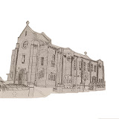 | Church of Our Lady Queen of Peace  and Blessed Margaret Pole  18 Douglas Road, Southbourne, Bournemouth BH6 3ER  01202 424960  Father Alex McAllister SDS & Deacon Roger Carr-Jones  amcallister@portsmouthdiocese.org.uk www.amcallister.org.uk | 
Father Alex 07788 415200 Deacon Roger 07342 818686
Parish Secretary: Robert Warr (Tue-Fri 9.30 to 12.30) olqp@portsmouthdiocese.org.uk
Twenty-second Sunday in Ordinary Time 31st August 2025
The man who humbles himself will be exalted

Mass Times
Sat 30th SS Margaret Clitherow, Anne Line & Margaret Ward
12.00
Sun 31st Twenty-second Sunday in Ordinary Time
9.30 Les Clark R.I.P.
11.00 People of the Parish
Mon 1st Feria
10.00
Tue 2nd Feria
10.00 Andrew McDonald Int.
Wed 3rd St Gregory the Great
10.00 with Holy Hour
Thu 4th St Cuthbert
No Mass
Fri 5th Feria CWL
10.00
Sat 6th Feria
12.00 Tony Hennesser R.I.P.
Sun 7th Twenty-third Sunday in Ordinary Time
9.30 Anthony Aga-in R.I.P.
11.00 People of the Parish
Tea & Coffee in the Parish Hall after Sunday masses
Children’s Liturgy (Sign in required) Sunday 9.30
Holy Hour after Wednesday morning mass
Confessions during Holy Hour Wednesday & at call
Choir Practice 18.00 Monday in Church
Psalter Week 2
Sunday Readings: Year C
Weekday Readings: Year 2
Baptisms Contact the Deacon
Marriages: Contact the Parish Priest
Rosary Group Fridays 10.30 when no Mother’s Prayers
Mother’s Prayer Group 2nd & 4th Fridays 10.30
Friendship Club 14.00 Fridays
Safeguarding & Data Protection Officer
Mary Basing 07969 120624
Cycle of Prayer: Ordinary Time: Summer
A deeper understanding between Christians and Jews, those who suffer persecution, oppression, and denial of Human Rights, Europe, human life, seafarers.
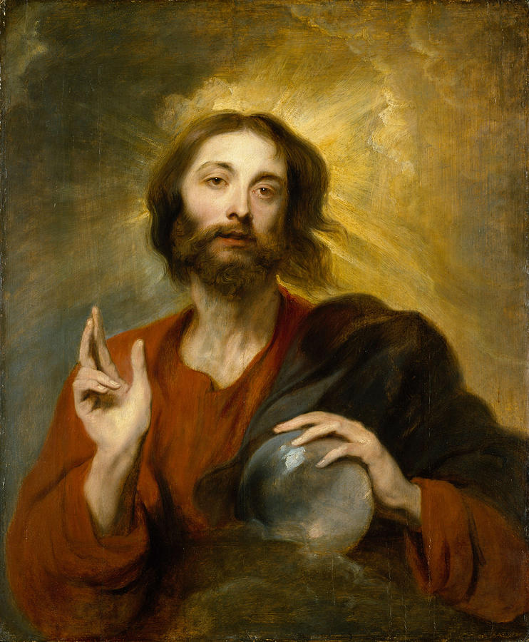
Salvator Mundi, Anthony Van Dyck 1620
A Prayer for all in Need
We bring before thee, O Lord,
the griefs and perils of people and nations;
the necessities of the homeless;
the helplessness of the aged and weak;
the sighing of prisoners;
the pains of the sick and injured;
the sorrows of the bereaved:
Comfort and relieve them,
O merciful Father,
according to their several needs;
for the sake of thy Son
our Saviour Jesus Christ.
Amen.

Little Church
Little Church resumes next Sunday. It would be good if a parent could accompany the younger ones.
Liturgy
There will be a meeting of the Liturgy Committee on Wednesday 10th September at 17.30 in the Presbytery.
Death leaves a heartache
no one can heal,
love leaves a memory
no one can steal

We will be holding our next Quiz Night in the Parish Hall on Friday 26th September at 18.30. Teams are limited to six persons with twelve tables in total. Entry £5 per adult and £3 per child under 16 years. Pay at the door. Fish Suppers will be available. Donations of raffle prizes most welcome. Come along test your wits and have a fun evening! Full details to follow.
Octoberfest
Octoberfest will take place on Saturday 25th October with live music, great food and lots of fun for all.
Autumn Talks
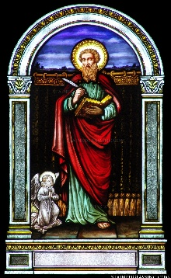 | We propose to hold a series of four talks on the Gospel of Matthew in the Autumn term. From the First Sunday of Advent we will be using Year A of the Lectionary and so for the coming year we will be mostly hearing the Gospel of Matthew read in the Liturgy.
These talks will give us the opportunity to get to grips with Matthew as an Evangelist. The Talks will be in the Parish Hall at 19.00 with refreshments.
Infancy Narrative 3rd October Father Alex
The Miracles 17th October Deacon Roger
The Parables 31st October Tony McCaffery
The Passion 7th November Father Alex
Those who think it is permissible to tell white lies soon grow colour-blind
Forthcoming Dates
Finance Committee 11th September
Parish Meeting 19th September
Quiz 26th September
Talk 3rd October
Talk 17th October
Octoberfest 25th October
Talk 31st October
Talk 7th November
Remembrance Day 9th November
 | School Masses  Please note that the masses on Tuesday 9th, Wednesday 10th, Thursday 11th and Friday 12th will be at 9.30 and they will be attended by pupils from St Peter’s School.
There will be no exposition of the Blessed Sacrament on Wednesday 10th September
Finance Committee
There will be a meeting of the Finance Committee on Thursday 11th September at 18.00 in the Presbytery.
General Parish Meeting
There will be a General Parish meeting on Friday 19th September at 19.00 in the Parish Hall. Any item of concern can be raised but an important matter under consideration will be the renovation of the presbytery. All are welcome.
Teach me my God and King
In all things thee to see;
And what I do in anything
To do it as for thee
George Herbert 1593-1632
Readers
We are looking for those willing to read at Sunday Mass, particularly young people. If you would like to volunteer, please inform Chrissie Evans who is drawing up a new rota. Contact: 01202 430768, evans_c17@sky.com.
Christian Initiation of Adults
If anyone is considering becoming a Catholic, please let Father Alex know so that a suitable course can be arranged. Normally the course would start in Advent and then conclude with reception into the Church at the Easter Vigil. Sometimes people have been coming to mass for years with their Catholic spouse but never taken the plunge. This might be just the opportunity you need to discuss your faith and consider whether you might take the next step.
Newsletter
If you wish to receive the newsletter by email, please notify: olqp@portsmouthdiocese.org.uk.
Recent Collections
Standing Orders £463, Last Sunday £578.62 with thanks.
Readers and Eucharistic Ministers
Readers: 9.30 M-C Marchesi & B Nanovo 11.00 T Hook, H Gardiner Ministers: 9.30 D Rogers 11.00 N Jean-Francois n/w Readers: 9.30 L Pritchard & T McCaffrey, 11.00 V Rochford, V Dybka
n/w Ministers: 9.30 M Smith 11.00 V Rochford

September Newsletter Extra

SECOND COLLECTIONS – The following second collections have been scheduled for the next few weeks.

Catholic Education Service |  | 14th September
Home Missions |  | 21st September
CAFOD |  | 5th October


CAFOD: Response in Gaza

Your donations to Gaza since the start of the conflict have been a vital lifeline. Right now, CAFOD's partner, Caritas Jerusalem, is delivering essential medical treatment to displaced people and providing medicines to treat chronic illnesses. We have helped 1,400 households with cash to buy supplies in the last month and we are currently feeding 2,000 people with new stocks of flour and rice. Despite the restrictions on aid coming into Gaza, CAFOD's local partners are working tirelessly to help people. And with your ongoing support, they will do all in their power to keep doing so. You can find out more about how you can make a difference in Gaza at cafod.org.uk. Thank you for backing our work through holding collections for our Family Fast Day appeals and for continuing to pray for peace in the Middle East.

REFRESHMENTS AFTER THE 09:30 MASS

£500 has been raised so far this year from donations for the post- 9.30 Sunday Mass Refreshments.
This will be evenly split between the Parish Church Roof fund and CAFOD.
Thank you so much for your generosity and support and to the wonderful team of helpers.
Refreshments will return on Sunday 7th September. We look forward to welcoming you back.

CWL CAFOD TEA

On Fri 3rd October 2-4pm
The Southbourne section of the CWL
Would like to invite you to an afternoon tea with speaker
To support the work of Cafod

CURRENT SCAM WARNING

Following the recent Online Safety Act there have been reports of fraudsters pretending to be Police Officers contacting people about ‘illegal online activity.’ These scammers try to persuade vulnerable people to hand over money or face conviction. Please help ensure that no one you know becomes a victim.
Report any attempts via 0300 123 2040 – Lines are open Monday-Friday 8am-8pm.

BOURNEMOUTH FOODBANK

Bournemouth Foodbank is calling for support, as winter is a time when people struggle the most, often choosing between heating and eating. If you’re able to donate food, money or time, they would be incredibly grateful for the support as the season changes. If you, your business or a group you’re a member of would like to support, get in touch with Niamh on niamh@bournemouth.foodbank.org.uk or donate to the crowdfunder today: https://www.crowdfunder.co.uk/p/feeding-bournemouth-together. Together we can help fight hunger in Bournemouth.

Due to your generosity, we have just transferred another £750 to this charity.

CORPUS CHRISTI PARISH

Youth Mass at Corpus Christi, Boscombe at 5pm on Sunday 7th September. Family gathering, football & hot dogs served on the beach, weather permitting.

Young Adults Group for those 18-35ish First meeting at 3pm on 20th September @ 22 Keswick Road BH5 1LR. Short walk, cream tea & a chance to discuss future events. More details, contact Nicola on 07932 142594

PARISH ARTS EXHIBITION

We are provisionally scheduling this fund raising event for late spring next year. We are planning for a mixed media show, so if you are interested in entering some of your work (or even selling it) please let the office know so I can gauge interest.

We will also be serving refreshments throughout the event.

RAFFLE PRIZES. The following people have unclaimed raffle prizes from the fete waiting for them in the office.

Ticket | Name | Phone ending in
95 | Jan Byrne
128 | McManus | 858
286 | Kevin ? | 635
342 | Adli Pabel ? | 839

DIOCESAN FORMATION DAYS for Ministers of Children’s Liturgy, Extraordinary Ministers of Holy Communion and for Readers – 06 September & 18 October

Fr Anthony Fyk, Director of Liturgy Formation, will be running further formation days for readers and
EMHC. The EMHC day will include a session on taking HC to the sick and housebound. The Readers’
Day will include a session on Lectio Divina.
Formation for Ministers of Children’s Liturgy will take place on 06 September, at St Bede’s,
Basingstoke, from 10.30 am to 1 pm. The programme will include prayer and reflection, sharing
good practice; working collaboratively; how to grow and communicate as Liturgical Catechists; Music
suggestions; and a wish list for future support, networking and how to find more helpers. Anyone
wishing to attend should register via liturgy@portsmouthdiocese.org.uk
Details can be found on the attached poster. They will take place at St Bede’s Church/Hall in
Basingstoke. Anyone interested is encouraged to register via liturgy@portsmouthdiocese.org.uk

EVERYONE HAS A STORY

As you may have heard I am also an author. I have been contemplating running a parish writer’s group to help people unlock their stories. It might your memoires so you can present your family with a copy of your life story or the novel you feel you must write.
If there is sufficient interest, I will cover a range of subjects everything from the basics of writing to publishing your work. If this might interest you. please email me in the office. Initially I would be asking for a donation to parish funds.

