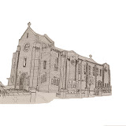 | Church of Our Lady Queen of Peace  and Blessed Margaret Pole  18 Douglas Road, Southbourne, Bournemouth BH6 3ER  01202 424960  Father Alex McAllister SDS & Deacon Roger Carr-Jones  amcallister@portsmouthdiocese.org.uk www.amcallister.org.uk | 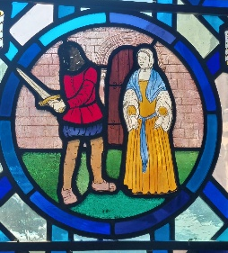
Father Alex 07788 415200 Deacon Roger 07342 818686
Parish Secretary: Robert Warr (Tue-Fri 9.30 to 12.30) olqp@portsmouthdiocese.org.uk
Twenty-first Sunday in Ordinary Time 24th August 2025
Strive to enter by the narrow door

Mass Times
Sat 23rd Feria
12.00
Sun 24th Twenty-first Sunday in Ordinary Time
9.30 John Simpson R.I.P.
11.00 People of the Parish
Mon 25th Feria
10.00 Oliver Lambie R.I.P.
Tue 26th Feria
10.00 Monica Heaton R.I.P.
Wed 27th St Monica
10.00 with Holy Hour
Thu 28th St Augustine of Hippo
No Mass
Fri 29th Passion of John the Baptist
10.00 Isly & Jean-Francois Families Int.
Sat 30th SS Margaret Clitherow, Anne Line & Margaret Ward
12.00
Sun 31st Twenty-second Sunday in Ordinary Time
9.30 Les Clark R.I.P
11.00 People of the Parish
Tea & Coffee in the Parish Hall after Sunday masses
Children’s Liturgy (Sign in required) Sunday 9.30
Holy Hour after Wednesday morning mass
Confessions during Holy Hour Wednesday & at call
Choir Practice 19.00 Monday in Church
Psalter Week 2
Sunday Readings: Year C
Weekday Readings: Year 2
Baptisms Contact the Deacon
Marriages: Contact the Parish Priest
Rosary Group Fridays 10.30 when no Mother’s Prayers
Mother’s Prayer Group 2nd & 4th Fridays 10.30
Friendship Club 14.00 Fridays
Safeguarding & Data Protection Officer
Mary Basing 07969 120624
Cycle of Prayer: Ordinary Time: Summer
A deeper understanding between Christians and Jews, those who suffer persecution, oppression, and denial of Human Rights, Europe, human life, seafarers.
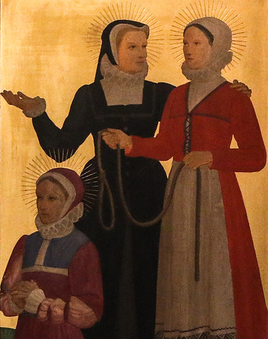
SS Margaret Clitherow, Anne Line
and Margaret Ward
The three martyrs we commemorate on 30th August are numbered amongst the Forty Martyrs of England and Wales. These women were all martyred because they protected Catholic priests from the authorities, who were seeking out priests for execution. During this dark time in history, it was illegal for priests to be in the country, as it was illegal for a Catholic to receive the Sacraments of the Church.
St Margaret Clitherow was a convert to the faith at the age of eighteen. Although her husband was not a Catholic, he supported her in the practice of her faith, along with their son Henry, who was studying for the priesthood. She welcomed priests into their home for the celebration of Mass, and in 1586 she was arrested for giving shelter to a priest. She was condemned to the horrifying death of being slowly crushed to death, being made to lay upon a sharp stone with a door placed upon her while nearly eight hundred pounds of stone were gradually added on top of the door. This took place on Good Friday in 1586. She died with the name of Jesus upon her lips.
St Anne Line was also a convert and was completely disowned by her family. In 1586 she married a man who was also a convert, but who was soon exiled, leaving Anne by herself. She managed two ‘safe houses’ where travelling priests could hide, but was arrested on 2nd February 1601, when she assisted a priest in escaping arrest. When brought to court, she fully admitted what she had done, and told the judge that her only regret was that she had not helped more priests. St Anne Line was hung in London, and before her death she again admitted her guilt but said that she wished she could have done it a thousand times.
St Margaret Ward was an unmarried woman who helped a priest escape from the prison by smuggling him a length of rope so he could lower himself over the prison wall. She was eventually accused of giving assistance to the priest because it was known that she was the last person to have visited him and so must have given him the rope. She was bound by chains, hung up by her hands, and was brutally scourged, as the authorities demanded to know where the priest had gone. She refused and was hung publicly in London on 30th August 1588.
These three martyrs were canonized in 1970 among the Forty Martyrs of England and Wales but also have their own particular feast day because of their great respect for the priesthood.
Earth provides enough to satisfy every man’s need
but not every man’s greed
Gandhi

Save the date for our next Quiz Night in the Parish Hall on Friday 26th September at 18.30. Teams are limited to six persons with twelve tables in total. Entry £5 per adult and £3 per child under 16 years. Pay at the door. Fish Suppers will be available. Donations of raffle prizes most welcome. Come along test your wits and have a fun evening! Full details to follow.
I'm only a spark, make me a fire,
I'm only a string, make me a lyre
Finance Committee
There will be a meeting of the Finance Committee on Thursday 11th September at 18.00 in the Presbytery.
General Parish Meeting
There will be a General Parish meeting on Friday 19th September at 19.00 in the Parish Hall. Any item of concern can be raised but an important matter under consideration will be the renovation of the presbytery. All are welcome.
Autumn Talks
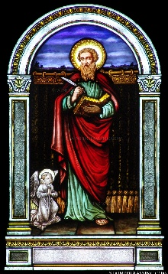 | We propose to hold a series of four talks on the Gospel of Matthew in the Autumn term. From the First Sunday of Advent we will be using Year A of the Lectionary and so for the coming year we will be mostly hearing the Gospel of Matthew read in the Liturgy.
These talks will give us the opportunity to get to grips with Matthew as an Evangelist. The Talks will be in the Parish Hall at 19.00 with refreshments.
Infancy Narrative 3rd October Father Alex
The Miracles 17th October Deacon Roger
The Parables 31st October Tony McCaffery
The Passion 7th November Father Alex
Christian Initiation of Adults
If anyone is considering becoming a Catholic, please let Father Alex know so that a suitable course can be arranged. Normally the course would start in Advent and then conclude with reception into the Church at the Easter Vigil. Sometimes people have been coming to mass for years with their Catholic spouse but never taken the plunge. This might be just the opportunity you need to discuss your faith and consider whether you might take the next step.
Support Your Parish
Contactless payments can be made by the machine in the Church. Cheques should be payable to ‘CDP Bournemouth Our Lady of Peace’. For Standing Orders go the parish website for the form or inform your bank of our details: 30-93-04 00875180. Donations can be made online or through the parish website.
He who knows others is wise;
He who knows himself is enlightened
Readers
We are looking for those willing to read at Sunday Mass, particularly young people. If you would like to volunteer, please inform Chrissie Evans who is drawing up a new rota. Contact: 01202 430768, evans_c17@sky.com.
Newsletter
If you wish to receive the newsletter by email, please notify: olqp@portsmouthdiocese.org.uk.
Recent Collections
Standing Orders £463, Collection £941.43 with thanks.
Readers and Eucharistic Ministers
Readers: 9.30 J Oliver & C Webb 11.00 C Wright & L Goodall Ministers: 9.30 T McCaffrey 11.00 L Hanson n/w Readers: 9.30 M-C Marchesi & B Nanovo 11.00 T Hook & H Gardiner n/w Ministers: 9.30 D Rogers 11.00 N Jean-Francoise

