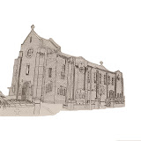 | Church of Our Lady Queen of Peace  and Blessed Margaret Pole  18 Douglas Road, Southbourne, Bournemouth BH6 3ER  01202 424960  Father Alex McAllister SDS & Deacon Roger Carr-Jones  www.amcallister.org.uk | 
Father Alex 07788 415200 Deacon Roger 07342 818686
Parish Secretary: Robert Warr (Tue-Fri 9.30 to 12.30) olqp@portsmouthdiocese.org.uk
Fifteenth Sunday in Ordinary Time 13th July 2025
Master, what must I do to inherit eternal life

Mass Times
Sat 12th Feria
12.00 Joe Tobin & Pat Cummins
Sun 13th Fifteenth Sunday in Ordinary Time
9.30 People of the Parish
11.00 Anthony Aga-in +
Mon 14th Feria
10.00
Tue 15th St Swithun
10.00
Wed 16th Feria
10.00 with Holy Hour
Thu 17th St Bonaventure
No Mass
Fri 18th Feria
10.00
Sat 19th Feria
No Mass Ordination at 11.00 in Cathedral
Sun 20th Sixteenth Sunday in Ordinary Time
9.30 People of the Parish
11.00 June Roche +
Tea & Coffee in the Parish Hall after Sunday masses
Children’s Liturgy (Sign in required) Sunday 9.30
Holy Hour after Wednesday morning mass
Confessions during Holy Hour Wednesday & at call
Choir Practice 19.00 Monday in Church
Psalter Week 2
Sunday Readings: Year C
Weekday Readings: Year 2
Baptisms Contact the Deacon
Marriages: Contact the Parish Priest
Rosary Group Fridays 10.30 when no Mother’s Prayers
Mother’s Prayer Group 2nd & 4th Fridays 10.30
Friendship Club 14.00 Fridays
Safeguarding & Data Protection Officer
Mary Basing 07969 120624
Cycle of Prayer: Ordinary Time: Summer
A deeper understanding between Christians and Jews, those who suffer persecution, oppression, and denial of Human Rights, Europe, human life, seafarers.
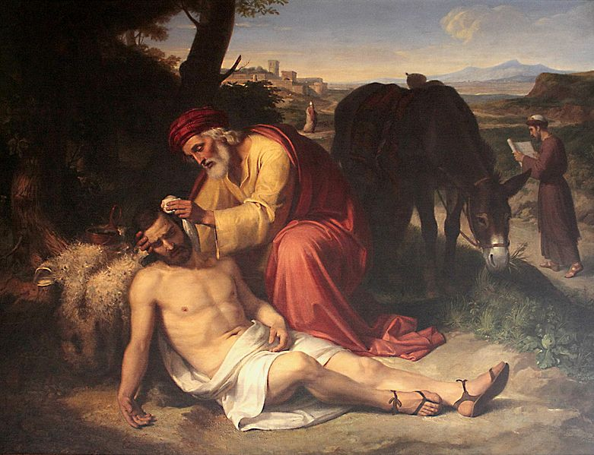
The Good Samaritan, Pelegrí Clavé 1838
The Parable of the Good Samaritan
This wonderful parable tells us a lot about social responsibility. We are not a series of individual persons but are part of a community and we each have a certain responsibility for the welfare of our brothers and sisters who are in need.
Of course, living as we do in a welfare state quite a lot of responsibility for the less fortunate is taken up by the state. But, as we know, the state relies on highly bureaucratic methods when it comes to the provision of welfare. This means that many people fall through the net and there is more hardship around us than we might think.
We ought to keep an eye out for those of our neighbours who may be in need. Of course, this mostly does not concern financial needs but rather things like loneliness or lack of mobility or depression and things like that. Some people may need practical help, but many others simply need companionship or a smiling face or some help with the shopping.
If our commitment to the Gospel is a serious one, then we ought to ensure that we are reaching out to those in need. Our Christian faith must not remain merely at an intellectual or spiritual level but must always have a practical and compassionate expression. Father Alex
Ryan Browne’s Ordination
Ryan Browne’s ordination to the priesthood will take place on Saturday 19th July at 11.00 in Portsmouth Cathedral. There will be no mass here on that day. We have booked a 60-seater coach which will be leaving Our Lady Queen of Peace promptly at 9.00 on 19th. There are only a few places left. If interested, please contact Father Alex.
The newly ordained Father Ryan will be saying mass here at 10:30 on Sunday 27th July with a reception afterwards. That will be the only mass on 27th. A collection is currently being taken up for Ryan and envelopes are available at the back of the Church.
You go to Church on Sunday so you can bring Christ to work on Monday
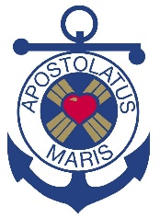 | Sea Sunday  Today is Sea Sunday, when we are invited to remember all those who live and work at sea. Seafarers are commonly recruited from poor countries where wages are low.
They work in extremely difficult and often dangerous conditions and suffer from loneliness, spiritual deprivation and even exploitation as they transport the goods we use and consume every day. A high proportion of seafarers are Catholics, and the Church owes them and other seafarers a duty of pastoral care. The Apostleship of the Sea (AoS) is the official maritime welfare agency of the Catholic Church in Great Britain reaching out to seafarers that visit our ports, offering pastoral and practical support. It is wholly dependent on voluntary donations. The retiring collection this Sea Sunday is your chance to help AoS make a difference to the lives of seafarers. Visit: apostleshipofthesea.org.uk.
Wicked men obey from fear;
good men, from love
Aristotle
A Prayer for Families
O God our heavenly Father, from whom every family in heaven and on earth is named; we entrust to your loving care the members of our families, both near and far. Supply their needs; guide their footsteps; keep them safe in body and soul; and may your peace rest upon our homes and upon our dear ones everywhere; for Jesus Christ our Saviour’s sake. Amen.
Holiday of Obligation
Please note that Friday 15th August, the Feast of the Assumption, is a Holiday of Obligation. Masses at 10.00 & 19.00.
Universalis
Readings, antiphons, etc for the day are available on the Universalis app available for free download. £9.99 for permanent access.

Parish Fête
We are holding our Parish Fête in the garden today from 12.00 to 16.00. BBQ, Cream Teas, Cakes, Plants, etc, etc. Come along for a wonderful afternoon with fun for all the family.
Going to University this Autumn?
 | Each University and Higher Education Institute in the country has its own dedicated Catholic Chaplain based either in the University or in the local parish. Masses each week are designed to meet the needs of the local students.
The Catholic Chaplaincy is a place for you to explore your faith, to meet people with similar interests from a wide range of backgrounds, and to get involved in activities and social outreach. If you already have a strong faith, this is a chance to deepen it. If you are full of questions and doubts, this the place to share them and search for some honest answers about life and faith. See www.catholicsatuniversity.org.uk.
If God can work through me,
he can work through anyone
St Francis of Assisi
Parish Office
NB Parish Office closed for holidays from 28th June to 16th July.
Father Alex McAllister
Father Alex will be on holiday from 31st July to 14th August. Please note that during this time there will be Sunday masses as usual but instead of weekday masses there will be a Communion Service at 10.00 on Mondays, Wednesdays and Fridays led by Deacon Roger Carr-Jones.
Support Your Parish
Contactless payments can be made by the machine in the Church. Cheques should be payable to CDP Bournemouth Our Lady of Peace. For Standing Orders go the parish website for the form or inform your bank of our details: 30-93-04 00875180. Donations can be made online or through the parish website.
Newsletter
If you wish to receive the newsletter by email, please notify: olqp@portsmouthdiocese.org.uk
Readers and Eucharistic Ministers
Readers: 9.30 J Carr-Jones, 11.00 V Rochford, V Dybka n/w Readers J Oliver, C Webb Ministers: 9.30 M Smith 11.00 H Gardiner n/w Ministers S Smith, L Goodall

