Su260524: Trinity Sunday PL38

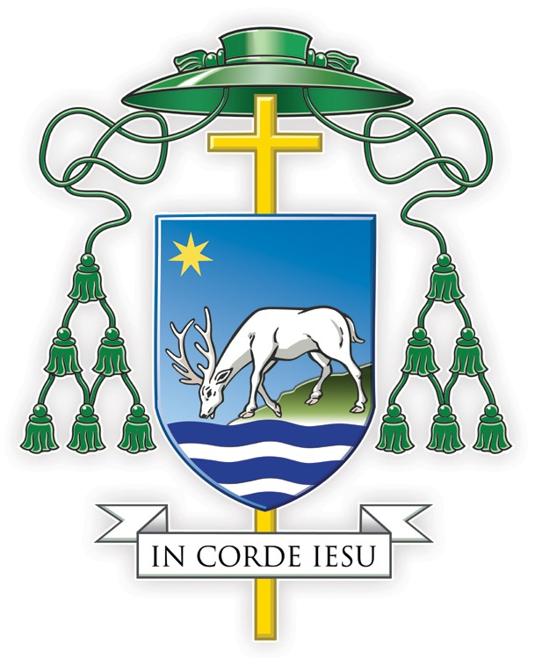

PASTORAL LETTER FROM THE BISHOP

appointed to be read

in all churches and chapels of the Diocese of Portsmouth

on Sunday 26th May 2024, the Most Holy Trinity.

PRAY EVERY DAY

Dearest Brothers and Sisters,

Today is the awesome feastday of the Most Holy Trinity, when we praise, thank and adore the one true God in the Mystery of His Godhead, a Trinity of persons: the Father, the Son and the Holy Spirit. He is our Creator; He is our Redeemer; He is our Sanctifier, because He is love; He is mercy; He is relationship. And all that He has created, visible and invisible, is stamped with His Trinitarian image. The whole universe, from the macro- to the micro-, from distant galaxies down to the tiniest atom, is marked by relationship and interdependence. So too, you and me. We are made in the image of the Trinity. Like God, we are made for love. Love alone makes us happy; we live to love, and love to be loved.

I write this Pastoral Letter today to encourage you in the first of our Six Holy Habits: prayer, to spend five minutes or more each day in prayer, whenever and wherever you find best, ideally using the Gospel reading of the day. It’s interesting how we live in an era when yoga, mindfulness and meditation is popular. This only demonstrates what Catholics have known for centuries: that for our psychological health and wellbeing, prayer is essential. Like hydration to the body, so is prayer to the soul. It is natural for humans to pray, yet we need to pray not just to achieve karma but to develop a personal relationship with God. Everyone can pray, Saint Francis de Sales wrote, “as long as they are capable of love. Only the devil is incapable of prayer,” he added, “because he is incapable of love.” Research shows that one reason many Catholics lapse or never practise their faith, is because they do not have - or do not even believe they can have - a real, life-changing friendship with God. Think of marriage or a friendship: how long would it last if we never spoke to each other, not even to ask ‘How are you?’ This is one reason we promote in the Diocese the Called and Gifted Programme. It helps people develop a closer friendship with God and a sense of being individually chosen by Jesus Christ to be His disciple.

I have a question for you: When you pray to God, to Which Person of the Blessed Trinity do you pray: the Father, the Son or the Holy Spirit? Though God is One, we have a different relationship with each Person. It’s this that makes prayer an exciting adventure. True, distractions come along; we can feel dry; we might struggle to find the right words, which is why using the Gospels and a prayer book is helpful. But let us take solace in the Holy Spirit, Who “helps us in our weakness,” expressing our pleas when we cannot seem to “pray properly.” Remember too there is only one prayer: the prayer of Jesus offered to the Father by the Holy Spirit. Think of an old radio-set and how you had to tune it in, to get the station. This is why when we begin a time of prayer, we should ask the Holy Spirit to align us with Christ and to unite us with the Father. Another help is to visit the Blessed Sacrament, to keep a period of silent contemplation, to say the Rosary, to recite the Liturgy of the Hours and to take part in the greatest prayer of all, the Mass. I also love speaking to God in my own words at various points during the day. So, let me ask you: When do you normally pray? How do you get on? Have you tried different types of prayer? What about group prayer?

At this period in the Cathedral, I am celebrating many Confirmation Masses and in the homily, I often speak to the young about a neglected doctrine of our Catholic Faith, the ‘indwelling of the Holy Spirit:’ that through Baptism, Confirmation and the Eucharist, if we are in a state of grace, God Himself lives within us. As St. Paul put it: “The Spirit of God has made His home in you.” This is what Jesus promised: “If anyone loves me he will keep my word and my Father will love him and we shall come to him and make our home in him.” It was this beautiful teaching that inspired St. Elizabeth of the Trinity to pray every day “Lord, make me your heaven, your beloved dwelling, the place of your rest.” Many people wrongly think of God as Up-There or a Light at the end of life’s long tunnel. No, God is within. He is living my life within me, sharing my experiences, sensing my feelings, my all. This truth can bring great consolation. I can speak with God anytime. Wherever I go, I am a living tabernacle of His presence. This is why I should have a profound respect for other Christians, clergy and faithful, and indeed, a love for all people, whatever their beliefs, for in them, in a way known only to Him, the Holy Spirit is at work.

“Go, therefore, make disciples of all the nations” says Jesus in today’s Gospel. “And know that I am with you always, yes, to the end of time”. Our mission-plan, You Will be My Witnesses, is about deepening faith, becoming more missionary and prudently managing our resources. As I have said often, it is easy to change the structures, and structural change is part of the plan. But You Will be My Witnesses is really about the hardest change of all: changing ourselves and making our parish and school communities more outward-facing, more missionary, and more focused on service of the needy. The basis of all this is spiritual renewal, deepening our prayer-life, renewing our faith and putting the Person of Jesus Christ at the centre. This is why we need to start with ourselves. We need to acknowledge that we could be holier. We need to repent and change our habits, rather than looking over our shoulders at others: “If only they would do that…” My prayer-life, my spirituality, my friendship with God, within Christ’s Body the Church, is paramount. So let me ask you: Could you find more time for prayer? Do you need help in prayer? Will you spend some time each day in prayer, using the Gospel of the day?

Thank you for listening. May the Blessed Mother, St. Edmund and your favourite saints obtain for you from the loving Heart of Jesus everything you desire.

In Corde Iesu

+Philip

Bishop of Portsmouth

The Preface of the Mass puts it so well: unus es Deus, unus es Dominus, non in unius singularitate personae sed in unius Trinitatae substanitae: ‘You are one God, one Lord not in the unity of a single person but in a Trinity of one substance’ The Roman Missal. English Translation according to the Third Typical Edition (London, CTS: 2010) 535
“We are made for goodness. We are made for love. We are made for friendliness. We are made for togetherness. We are made for all of the beautiful things that you and I know. We are made to tell the world that there are no outsiders. All are welcome: black, white, red, yellow, rich, poor, educated, not educated, male, female, gay, straight, all, all, all. We all belong to this family, this human family, God's family” Archbishop Desmond Tutu Desmond Tutu Peace Foundation: https://www.facebook.com/DesmondTutuPF (May 2024)
See Pope Benedict XVI ‘Angelus. Solemnity of the Most Holy Trinity, St. Peter's Square, Sunday, 7 June 2009’: www.vatican.va (May 2024)
One of the things I find very impressive in our Diocese of Portsmouth is meeting many members of our clergy and also many members of our laity who spend a substantial amount of time each day in prayer.
Cited by Sr. Susan Marie ‘More on Prayer’ (Mar 28, 2022): https://visitationspirit.org (May 2024)
See S. Weddell Forming Intentional Disciples (Huntingdon, Our Sunday Visitor: 2012) 15-47
For more on this, see https://www.calledandgifted.org.uk (May 2024)
As St. Paul says: “The Spirit too helps us in our weakness. For when we cannot choose words in order to pray properly, the Spirit Himself expresses our pleas in a way that could never be put into words, and God who knows everything in our hearts, knows perfectly well what he means, and that the pleas of the saints expressed by the Spirit are according to the mind of God” (Rom 8: 26-27)
“There is no other way of Christian prayer than Christ. Whether our prayer is communal or personal, vocal or interior, it has access to the Father only if we pray "in the name" of Jesus. The sacred humanity of Jesus is therefore the way by which the Holy Spirit teaches us to pray to God our Father” (CCC 2664)
Rom 8: 9
John 14: 23
Elizabeth of the Trinity I have Found God. Complete Works Volume I. General Introduction and Major Spiritual Writings transl. Sr. Aletheia Kane OCD (Washington, ICS Publications: 1984) 183.
“Since all human beings are in fact called to one and the same destiny, which is divine, we must hold that the Holy Spirit offers to all the possibility of being associated, in a way known to God, with the Paschal Mystery" John Paul II Dominum et Vivificantem (London, CTS: 1986) n. 53.
Mt 28: 19-20
See www.portsmouthdiocese.org.uk/our-mission/planning/ten-year-plan/ (May 2024)
Pope Francis puts it well: “There is a real risk of “complacency, the attitude that says: ‘We have always done it this way’ (Evangelii Gaudium, 33) and it is better not to change. That expression – “We have always done it that way” – is poison for the life of the Church. Those who think this way, perhaps without even realising it, make the mistake of not taking seriously the times in which we are living. The danger, in the end, is to apply old solutions to new problems. A patch of rough cloth that ends up creating a worse tear (cf. Mt9:16).” Pope Francis Address Of His Holiness Pope Francis For The Opening Of The Synod (Saturday, 9 October 2022): www.vatican.va (May 2024)

